**Problem**: AI-Generated Medical Research Papers

**Graphical Solution**:

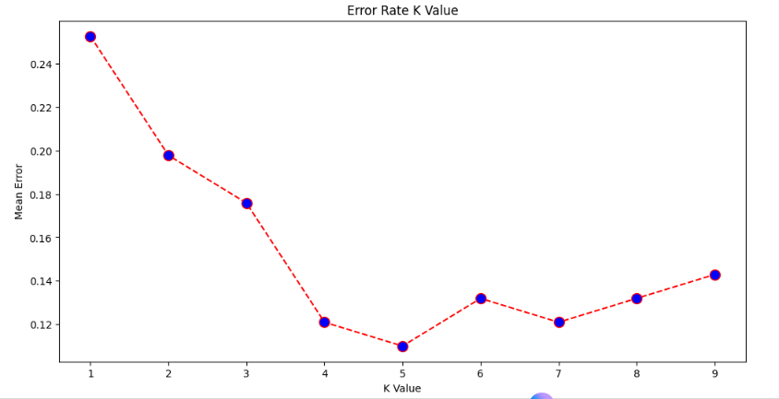

**Execution Output:**

